Prepare Multiple Nodes on Alibaba Cloud

A.1. Purchase Single Node on Alibaba Cloud
Step 1: Click this
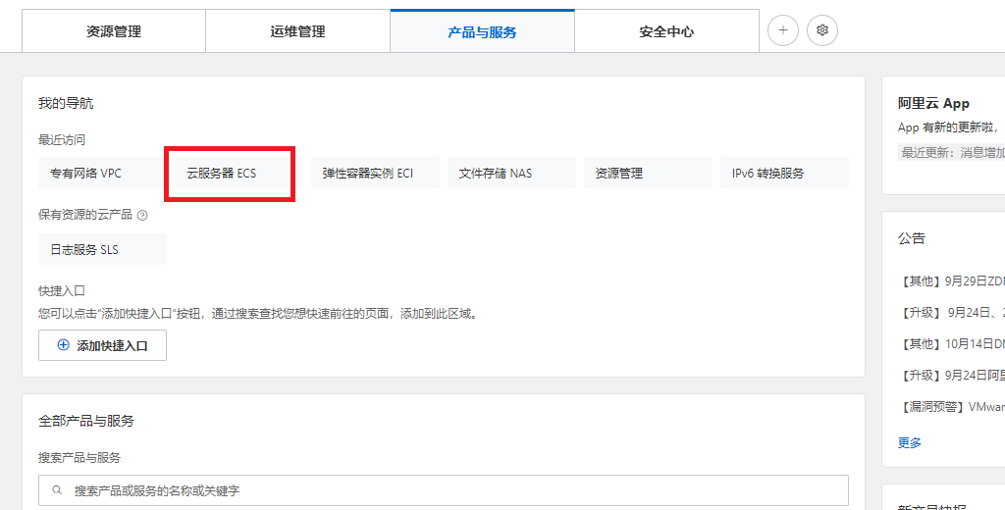
Step 2: Create a new inoose no IPv4 address, choose your password Y0urpassword,

A.2. Purchase a NAT Gateway

Step 1: Click https://vpc.console.aliyun.com/nat/cn-guangzhou/nats, purchase 2 public IP addresses, create a NAT gateway,

Step 2: After purchasing 2 public IP addresses, we have 8.163.56.8 and 8.138.164.210,

Run Multi-Nodes Fabric (Exp 1: 1 CLI + 2 Peers + 1 Orderer)

1.1. Prepare the Hosts

Step 1 (Prepare): All machines prepare the host names,
$ vi /etc/hosts

172.31.210.67 cli
172.31.210.70 peer0.org1.example.com
172.31.210.71 peer0.org2.example.com
172.31.210.72 orderer.example.com

Step 2 (Prepare): CLI p
chines including peers and orderers

